SIMATS ENGINEERING
ASSESSMENT TOOL 1

Experiments

COURSE NAME: OBJECT ORIENTED ANALYSIS AND DESIGN COURSE CODE: CSA1153

COURSE OUTCOME COVERED

CO3: Analyze system requirements using object-oriented techniques to identify classes, attributes, and relationships and develop use case models. (BL4)

Assessment Tool Weightage: 40%

Annexure A

Code of Conduct:
I Niranjana M (192511240) (Name / Reg No) certify that this submission is my original work and that I have adhered to the guidelines specified for this assessment.
I understand that any violation of academic integrity rules will result in disciplinary action.

Signature of the student:

RUBRICS FOR CALCULATION:

Experiments

Criteria | Weightage | Level 4 – Exemplary | Level 3 – Proficient | Level 2 – Developing | Level 1 – Beginning
Understanding of Concepts | 25 | Demonstrates thorough understanding and effectively integrates multiple concepts/technologies | Good understanding with proper integration of most concepts | Basic understanding; limited or partial integration | Poor understanding; unable to integrate concepts
Experimental Design | 30 | Well-planned, systematic implementation with  optimal solution | Correct implementation with minor  issues | Basic implementation with errors or  inefficiencies | Incorrect or incomplete implementation
Use of Tools | 20 | Effective and advanced use of tools/technologies with  proper configuration | Appropriate use of tools with correct  execution | Limited or inconsistent use of tools | Incorrect or minimal use of tools
Analysis of Results | 15 | Insightful analysis with accurate interpretation and validation of results | Good analysis with reasonable interpretation | Basic analysis with limited insights | Poor or incorrect analysis of results
Documentation | 10 | Clear, well-structured documentation with diagrams, code, and  results | Organized documentation with necessary  details | Basic documentation with missing  details | Poor or incomplete documentation

(O) Library Management System
1. Use Case Diagram
Actors:
- Librarian
- Student
Use Cases:
- Add Book
- Update Book Details
- Remove Book
- Search Book
- Request Borrow Book
- Verify Availability
- Issue Book
- Return Book
- Calculate Fine
- Notify Student
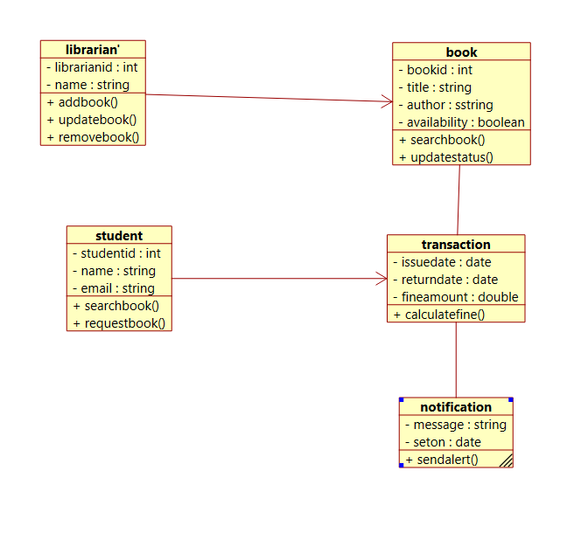

FIG 1. CLASS DIAGRAM
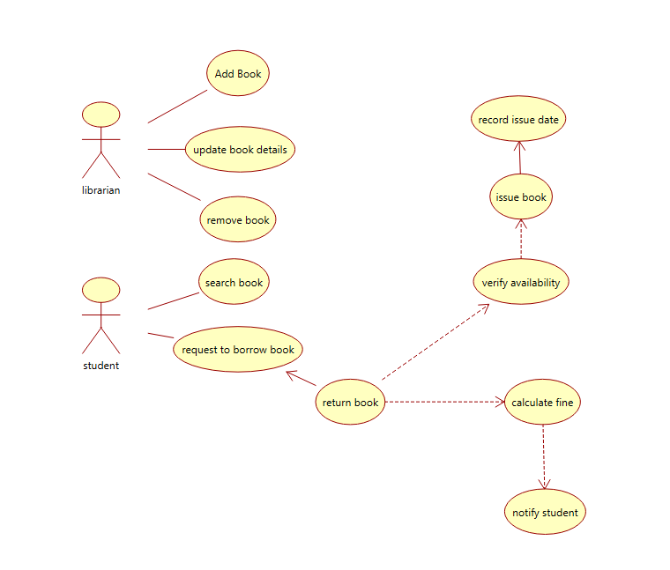

FIG 2. USE CASE DIAGRAM

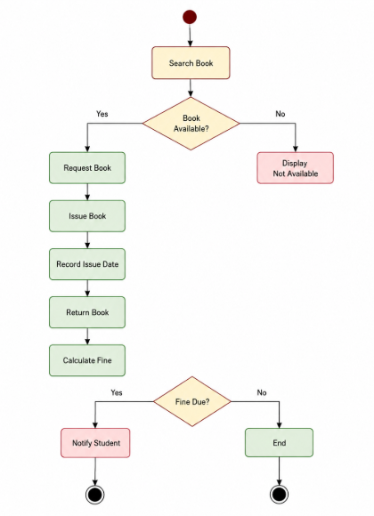

FIG 3. ACTIVITY DIAGRAM

(p) Hospital Appointment System
1. Use Case Diagram
Actors:
- Patient
- Receptionist
- Doctor
Use Cases:
- Register Patient
- Book Appointment
- Check Doctor Availability
- Confirm Appointment
- Update Schedule
- View Appointment List

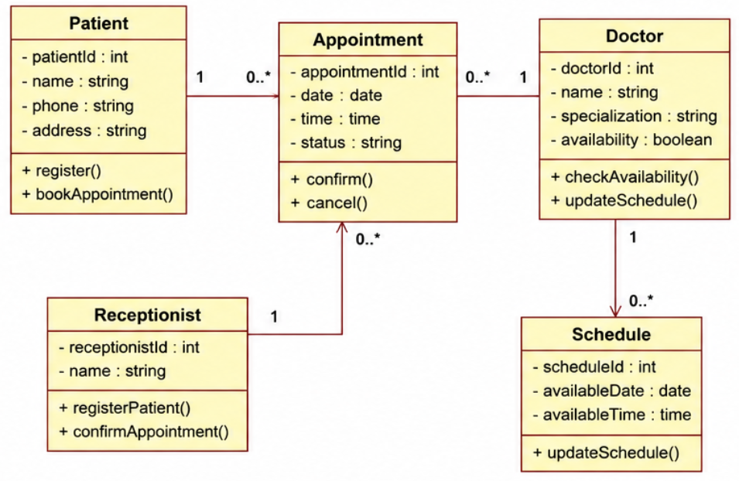
FIG 4. CLASS DIAGRAM

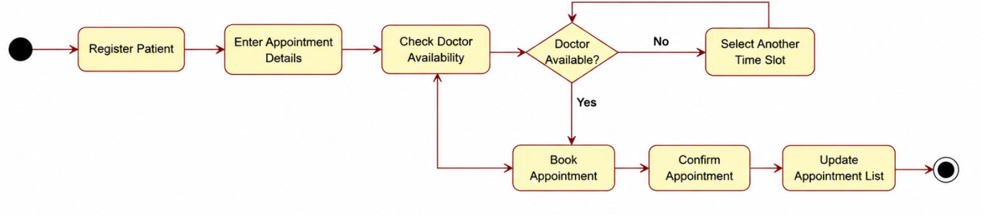

FIG 5. ACTIVITY DIAGRAM

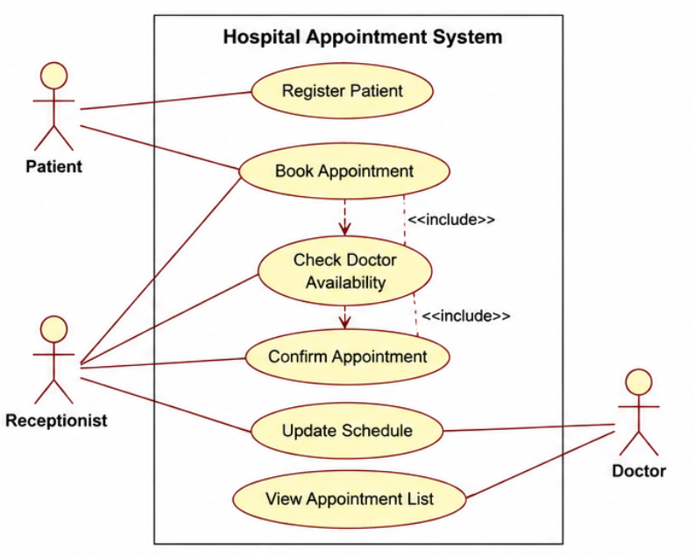
FIG 6. USE CASE DIAGRAM

